Linux commands

Pwd – shows current directory

ls – lists all files

ls -a –lists hidden files

Ls –l- lists files along with their properties

mkdir – creates directory

rmdir – removes directory

cd – change directory

rmdir – r removes branches of directory

vi filename.extension creates a file

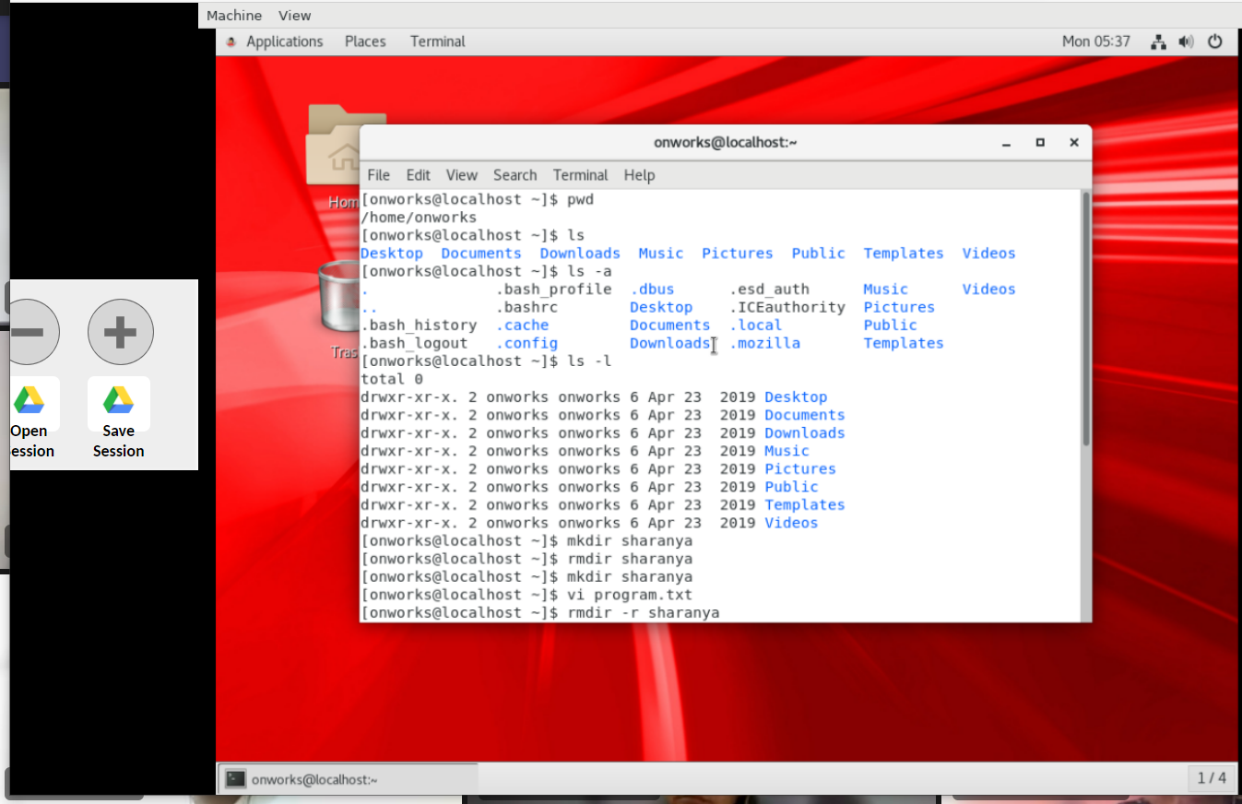

df command provides disk space

df –h proves disk space in Mb or gb, human readable format

* ps command gives information about the process running
* ps process id displays status of the process whose process id is mentioned
* gedit filename.txt opens the file in notepad terminal
* gedit filename.extension & makes the process run in the background
* Ps –a displays the hidden process
* Kill is used to kill a process
* Kill process id kills a process whose process id is mentioned
* Sudo/su command gives super user privilege sudo apt-get install chrome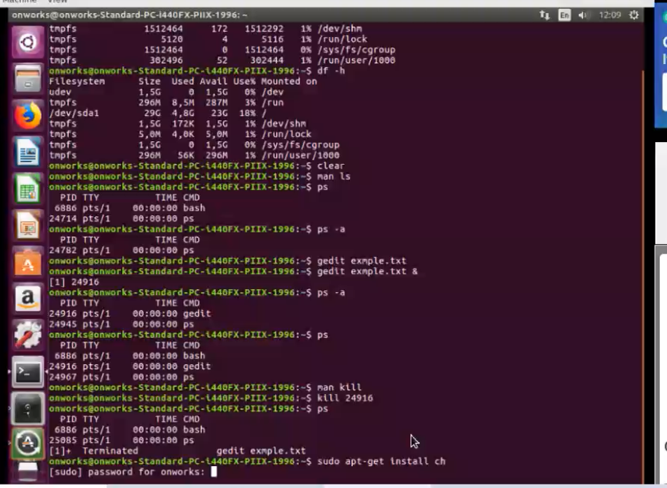
* free – information about memory
* free –h information about memory in human readable format like mb gb.
* lshw – provides system configuration
* lscpu – information about cpu
* lsusb – information about usb device of the system.

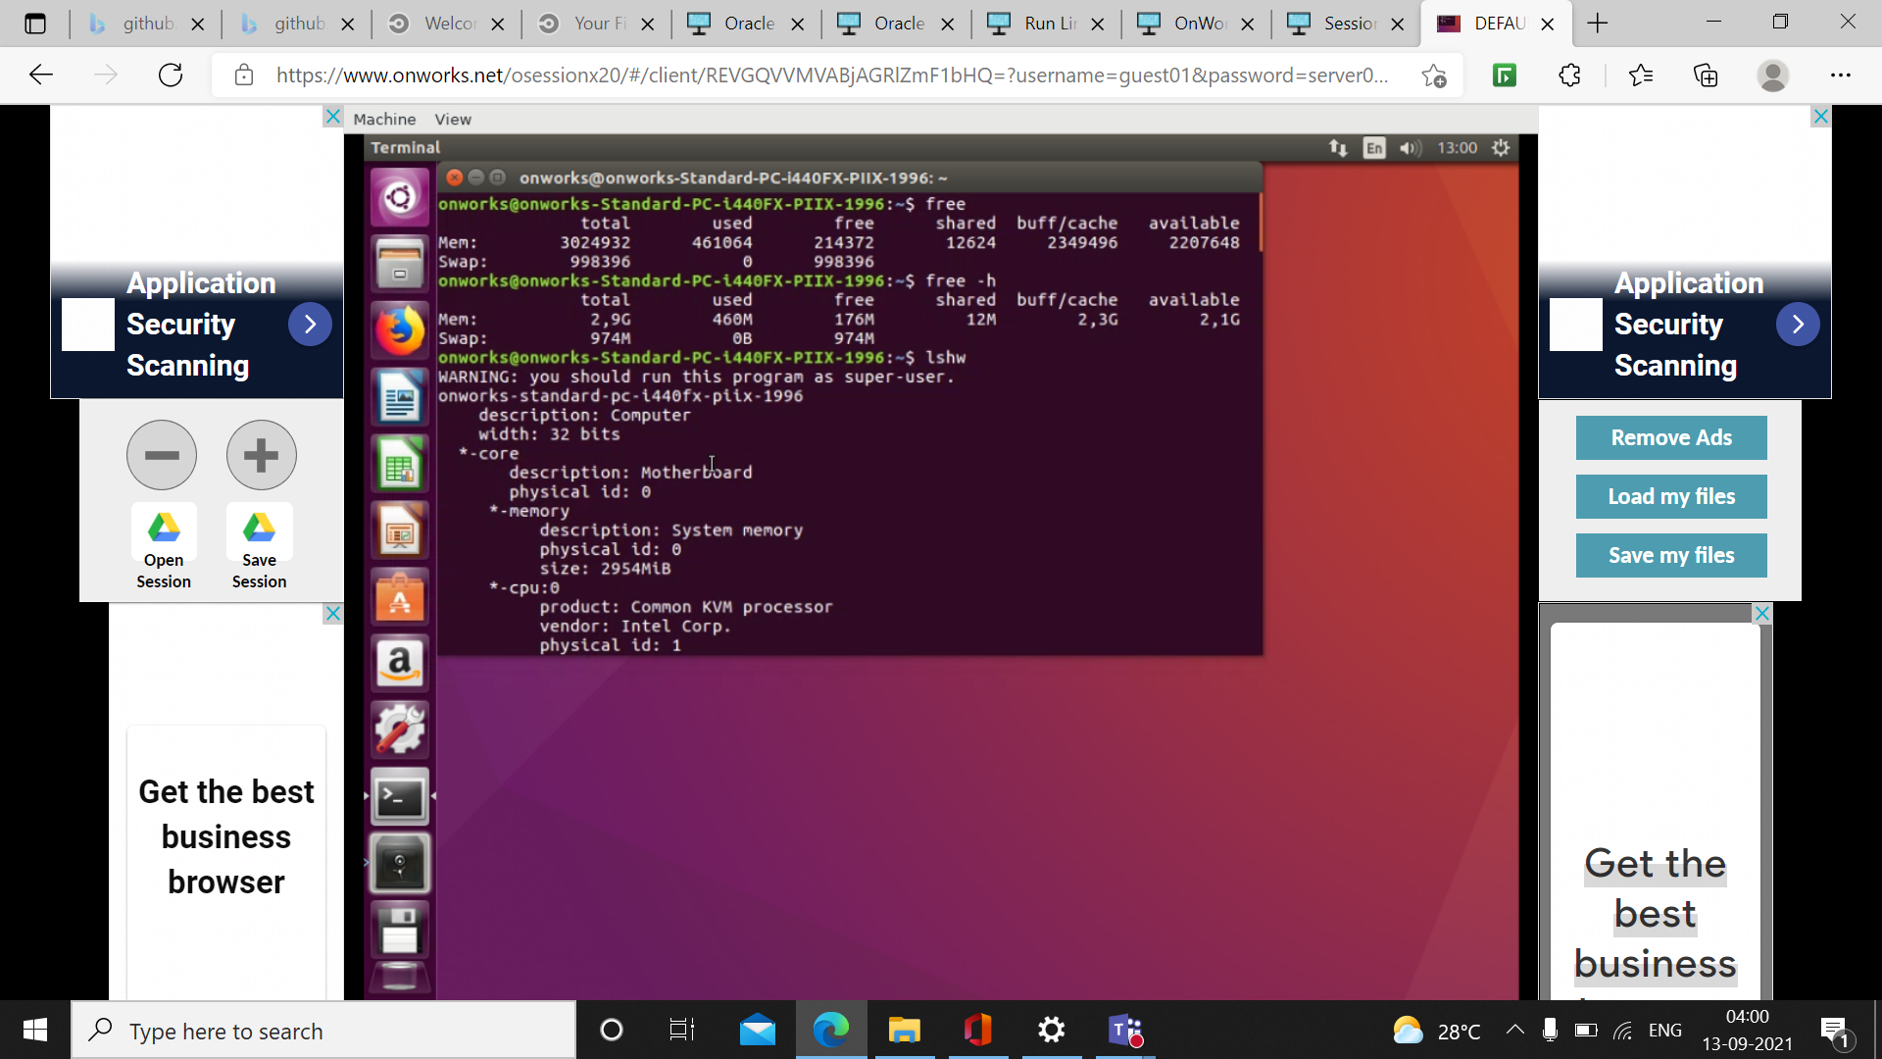

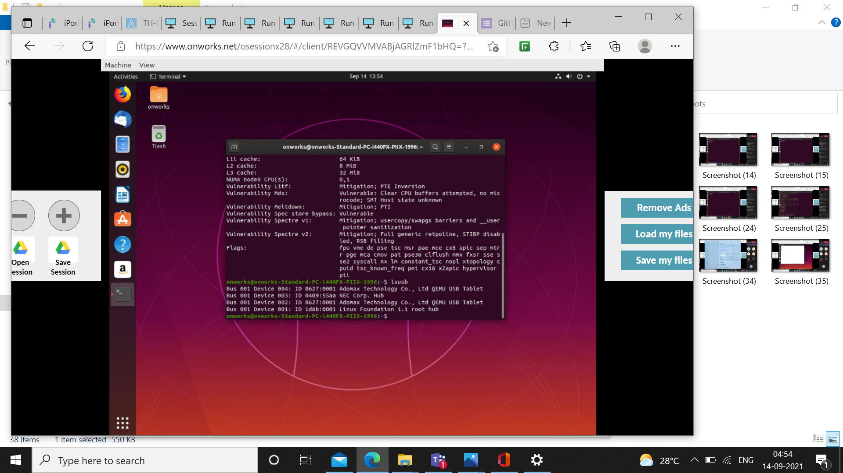

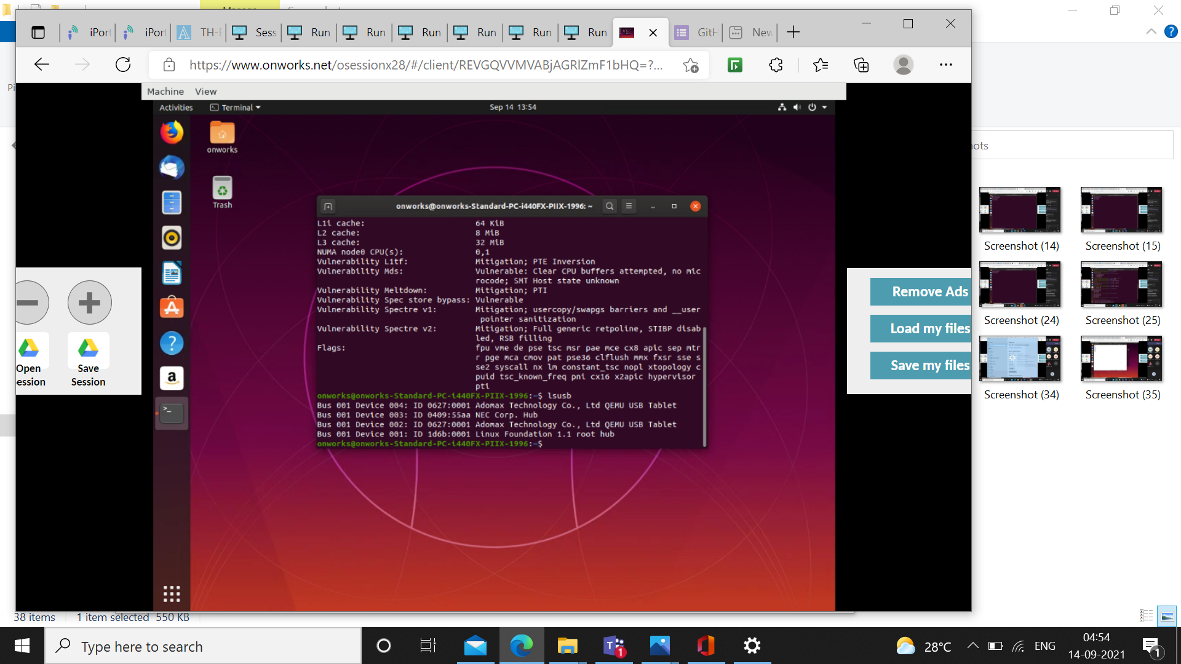

* Cat – displays the contents of the file
* Cat>filename.extension - replaces the contents of the file with whatever text entered in the editor
* Cat file1.txt file2.txt - copies the contents of file1 to file2
* Chmod – used grant read write execute permission to the file.

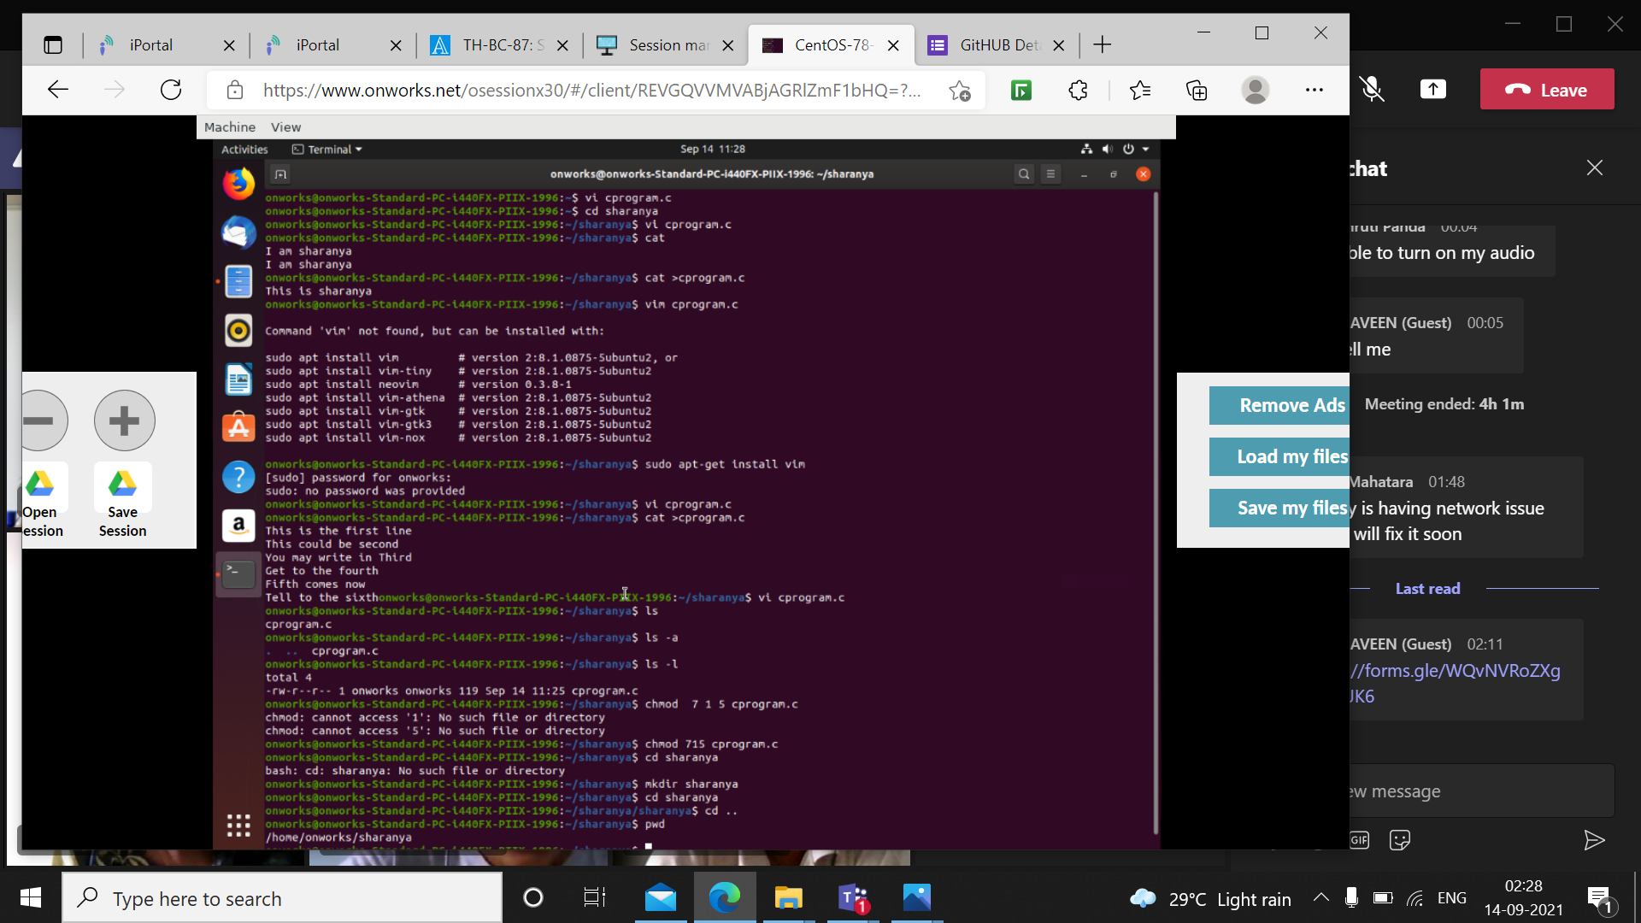

Vi editor commands

:wq – to save and exit from the file

:q to exit without saving

:exit- to exit

:set number- a column of line numbers appears at the left

Before :set numer

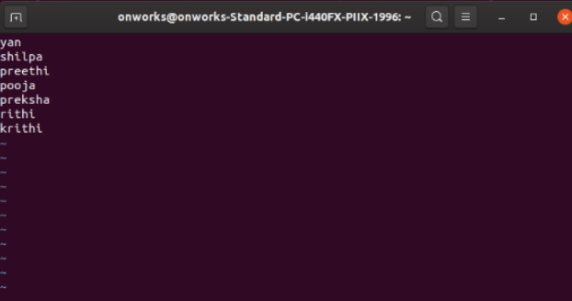

After :set number

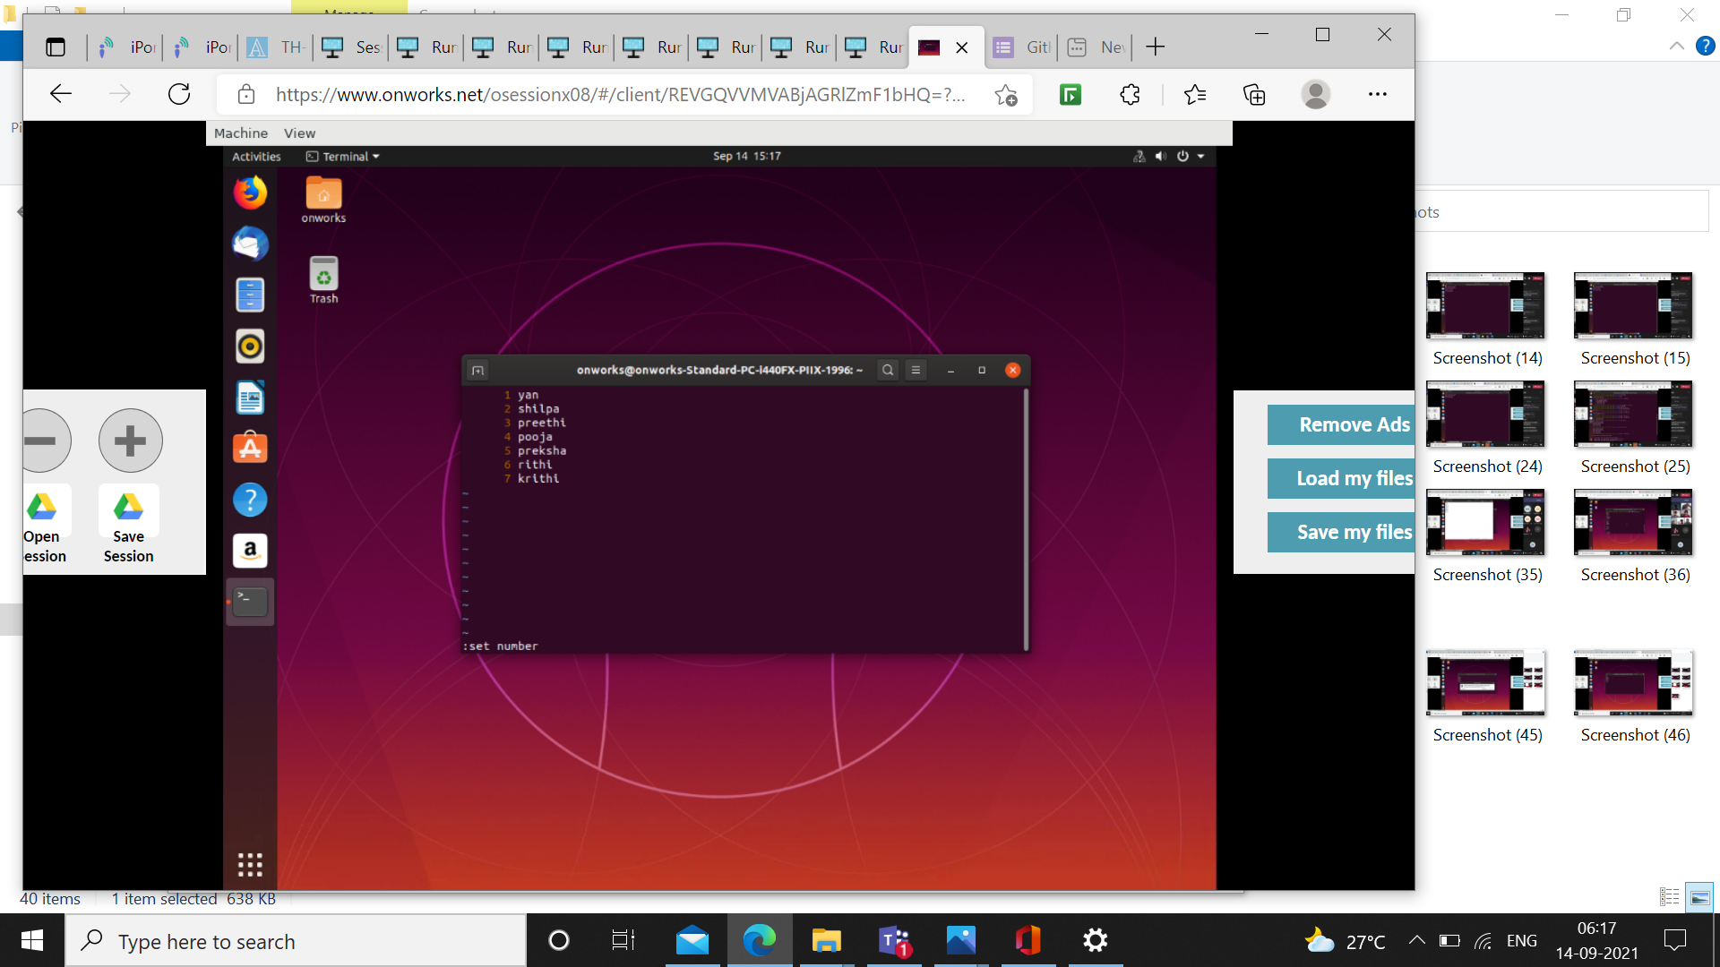

* dd – deletes the line the cursor is present in.

Before dd command

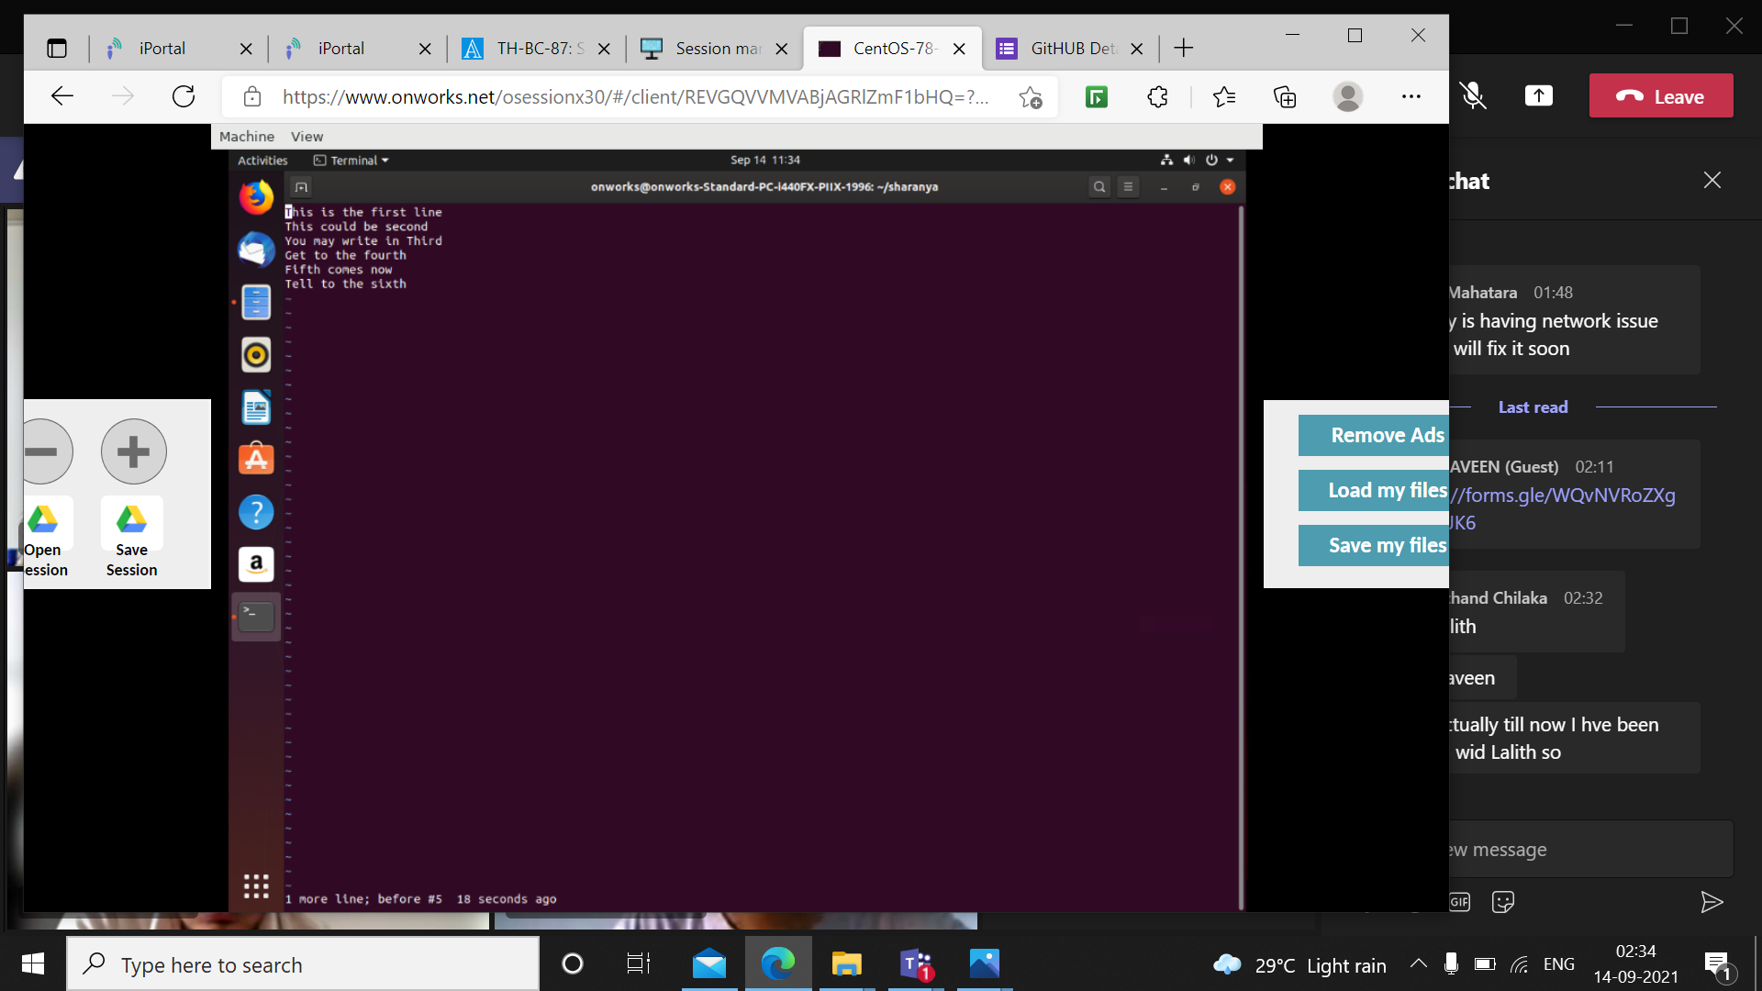

After dd command

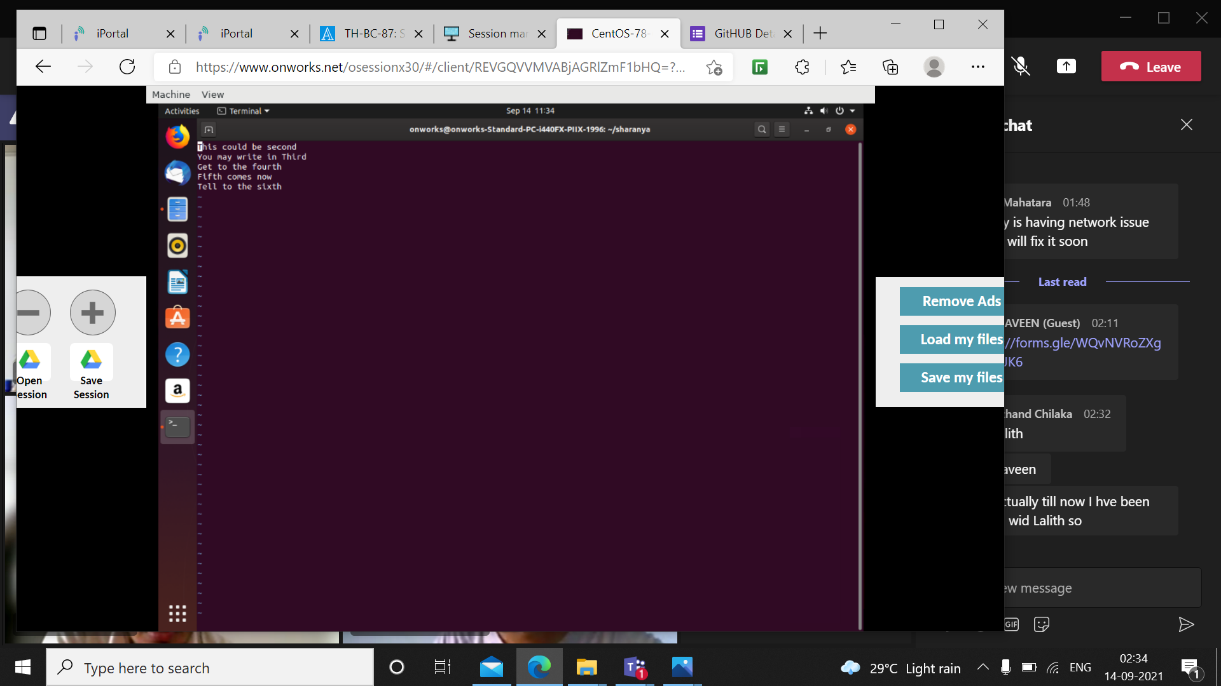

* u - undo the action of deleting



* r - place the cursor on the letter you want to edit the letter, press r and the letter to be replaced.

Here, first letter of the file is replaced ftom ‘T’ to ‘t’ using r command.

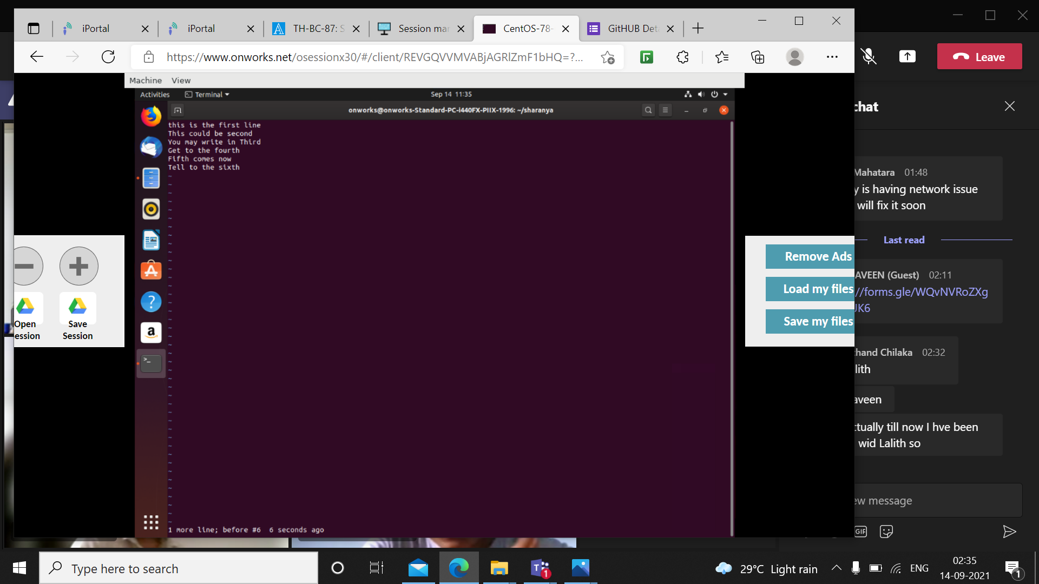

* e takes you to the end of the word

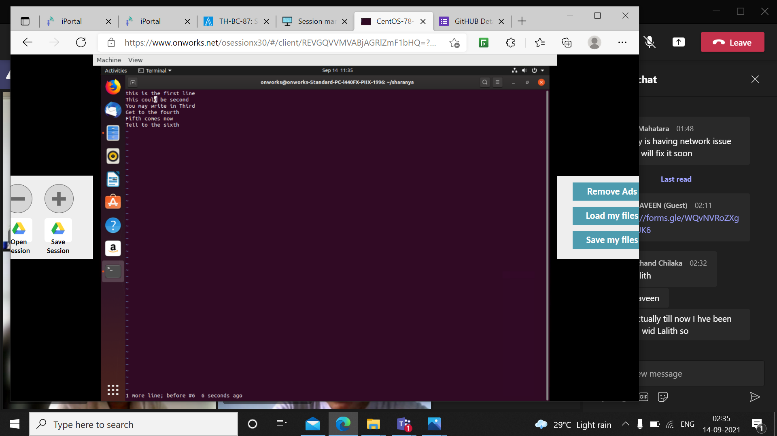

* x– delete single character, acts as backspace.

Here, the last letter d of could is deleted using x command

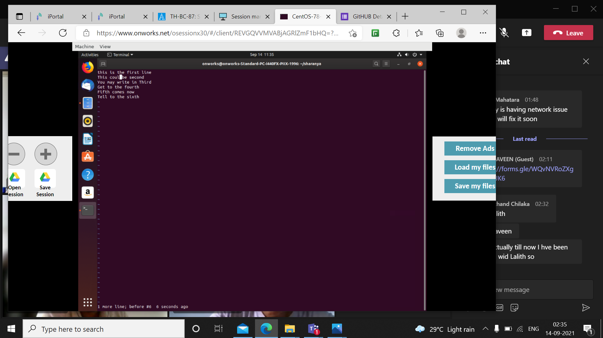

* yy command is used to copy a line and p is used to paste.

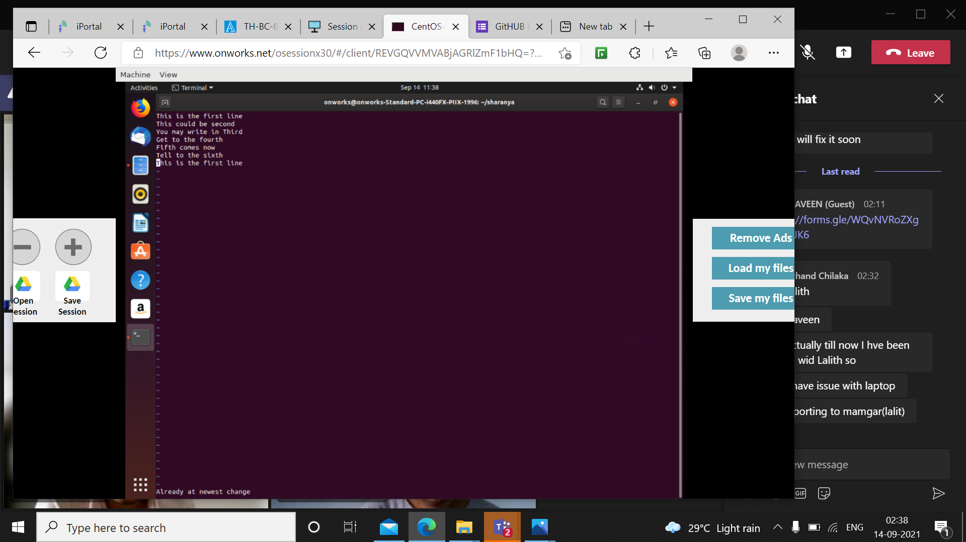

Here, the first line of the text file is copied and pasted at the end using yy and p command



* d – you can delete many lines by using d command along with number of lines.

Here, the cursor is place at the second line and given the command d2, which deleted the third and fourth line.

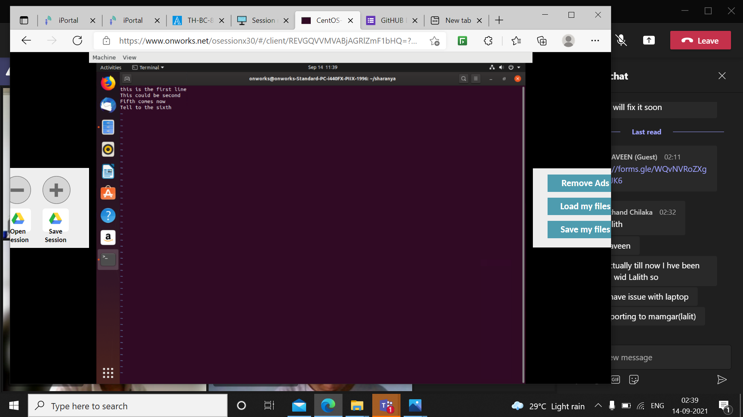

* Grep command is used for pattern matching.
* Grep word filename.extension looks for the word in the file.
* Grep –c filename.extension returns the number of times the word is present in the file
* Grep –n filename.extension returns the line number along with the line in which the word is present
* Grep -I filename.extension returns the word irrespective of its case.
* Head command returns the first 10 lines of file
* Head –n along with some number returns the same number of lines from the top of the file.
* Tail returns last 10 lines from the file
* Tail along with some number returns the same number of lines from the bottom of the file

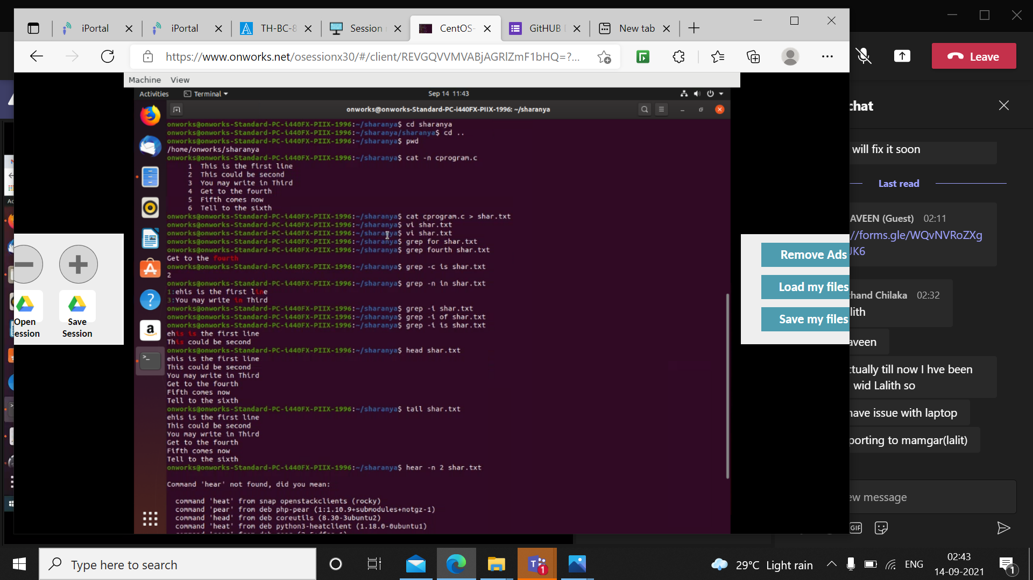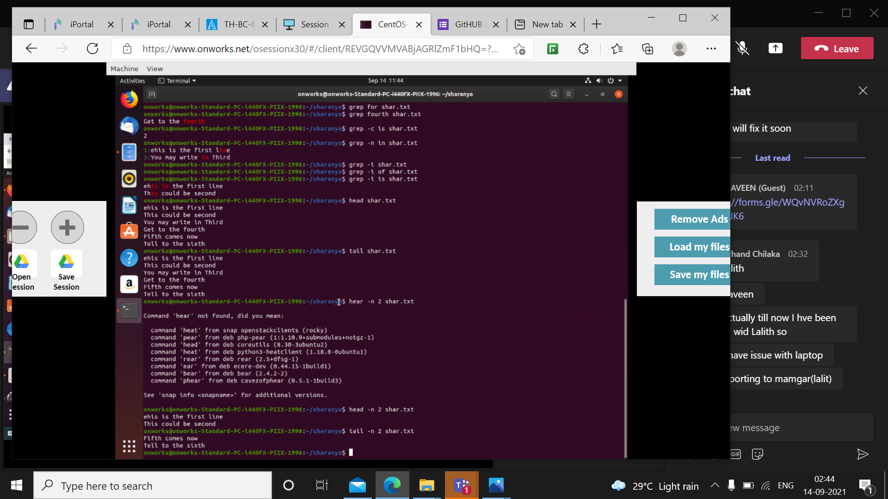

* history command displays all the commands used so far
* wget returns whether the link entered is valid or not
* ip r returns the ip address

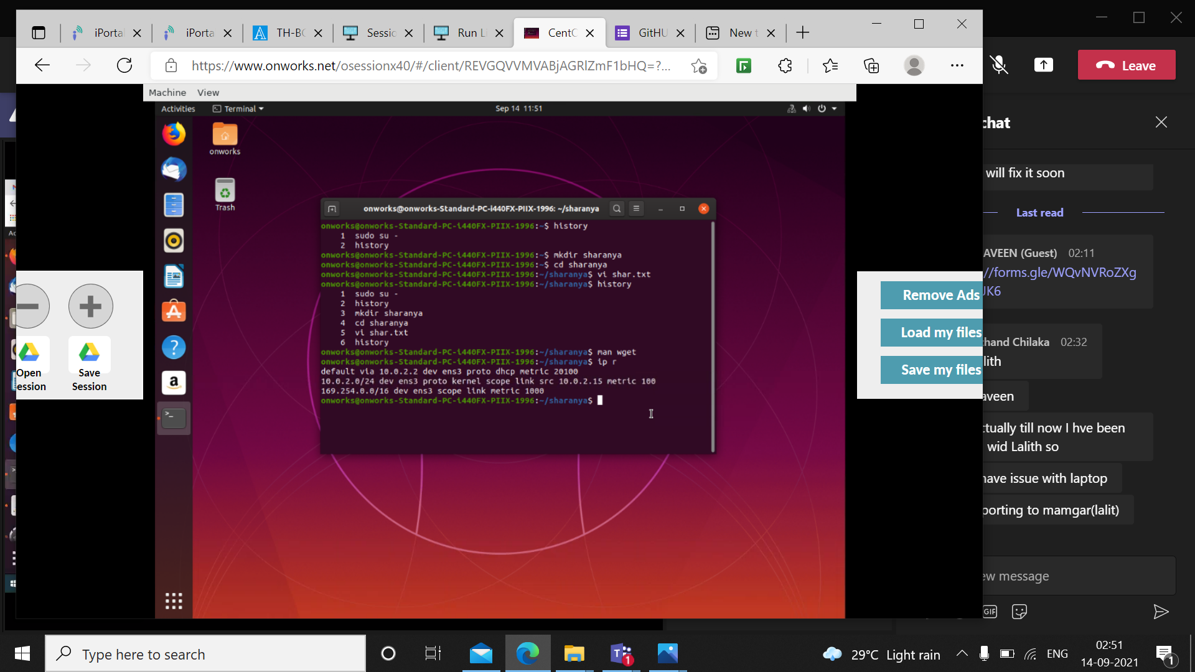

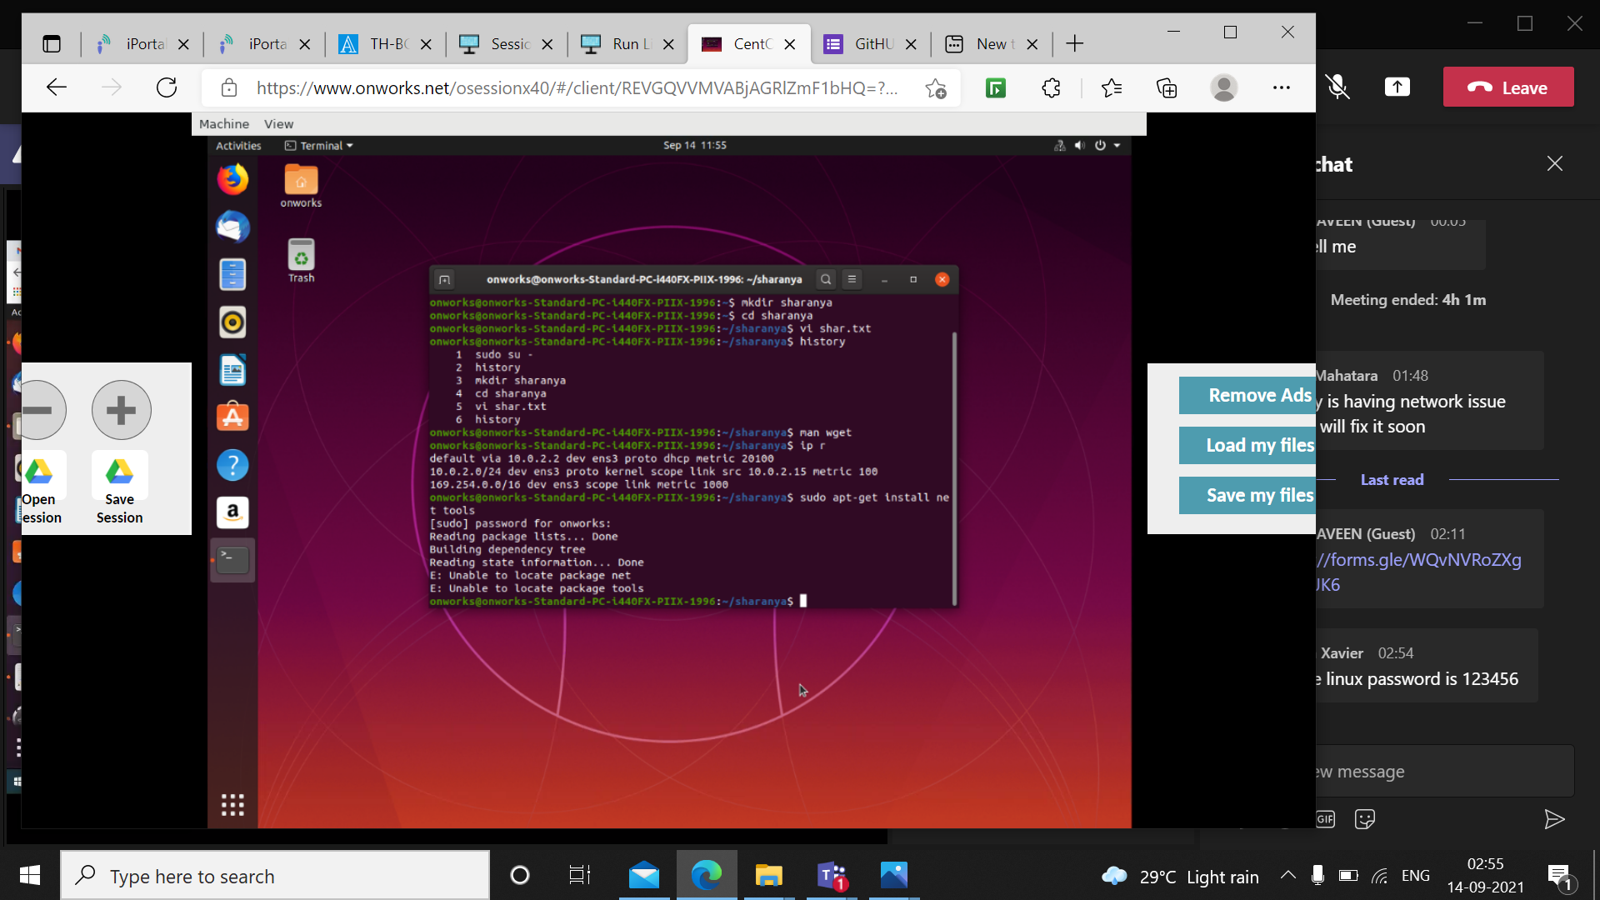

* Who command returns who is accessing the system

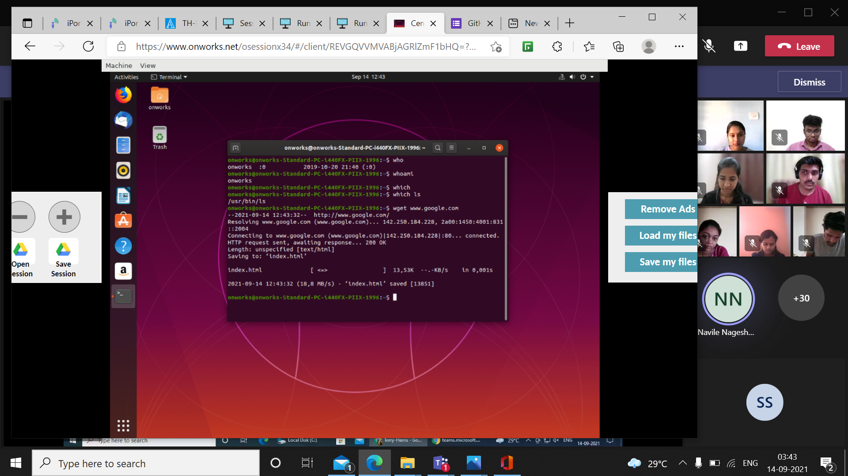

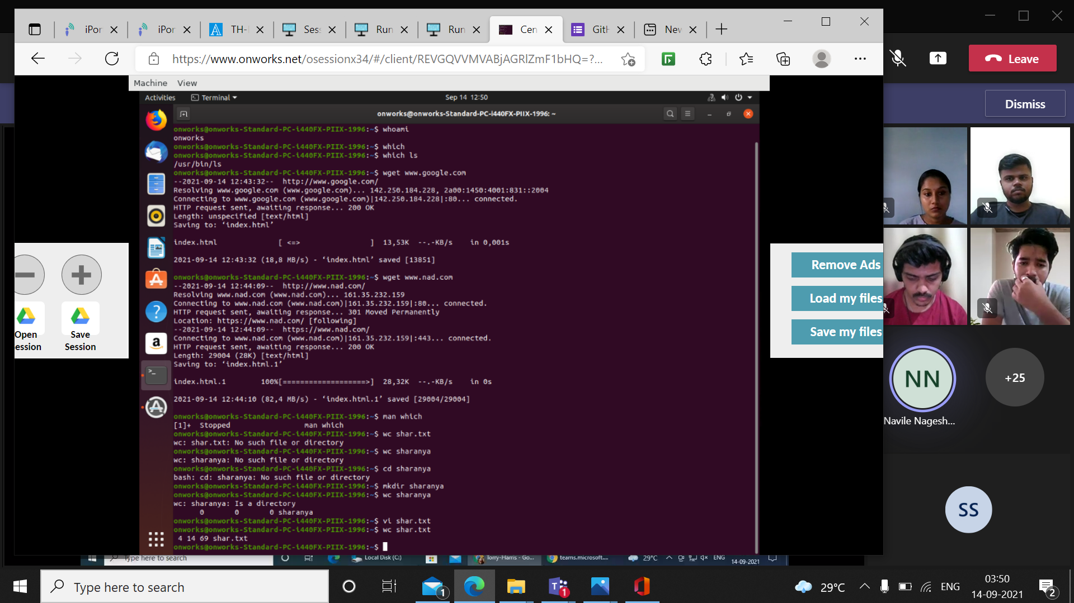

* Sort command sorts the list entered into ascending order
* Sort –r command sorts in reverse order

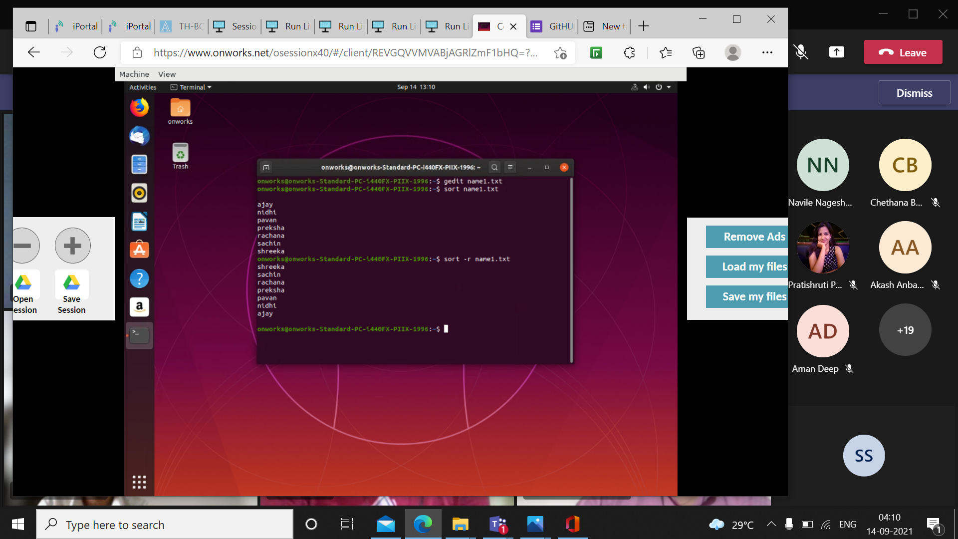

Name1.txt

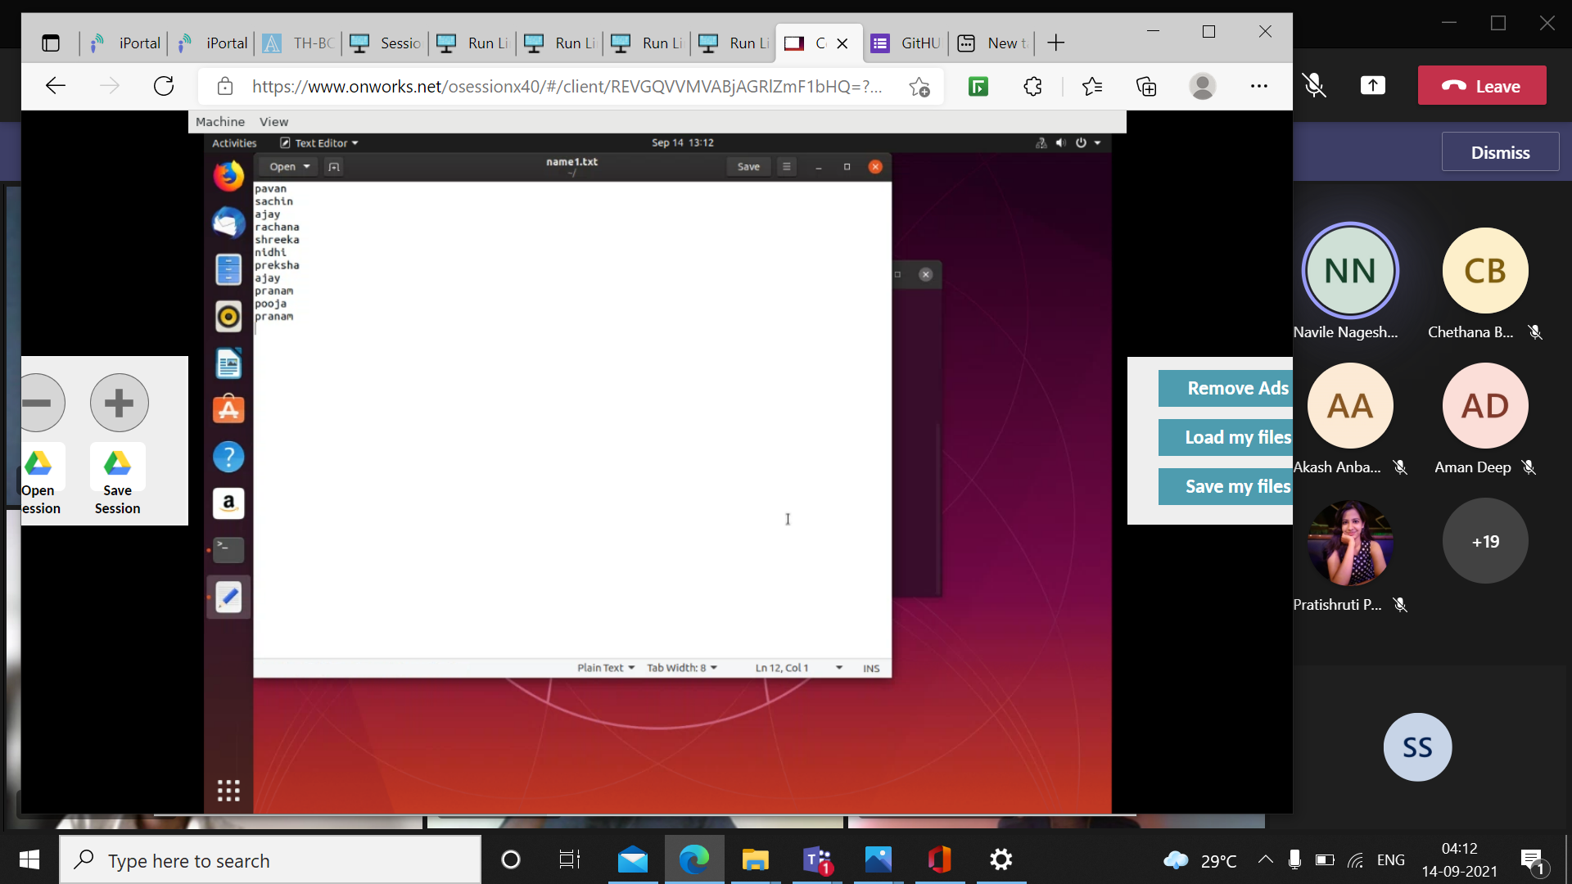

Name2.txt

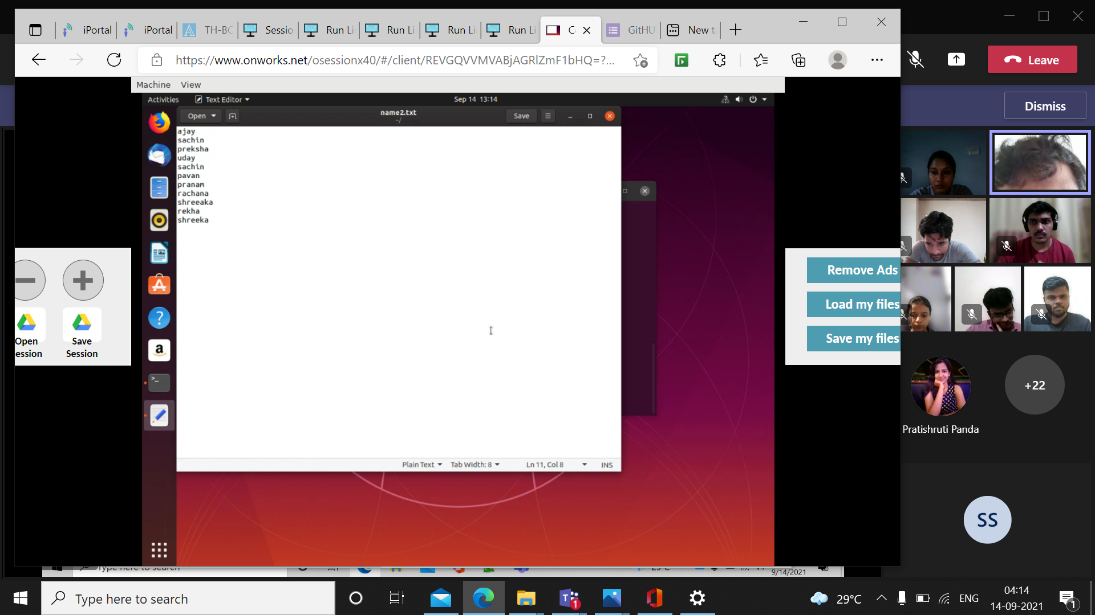

Name3.txt

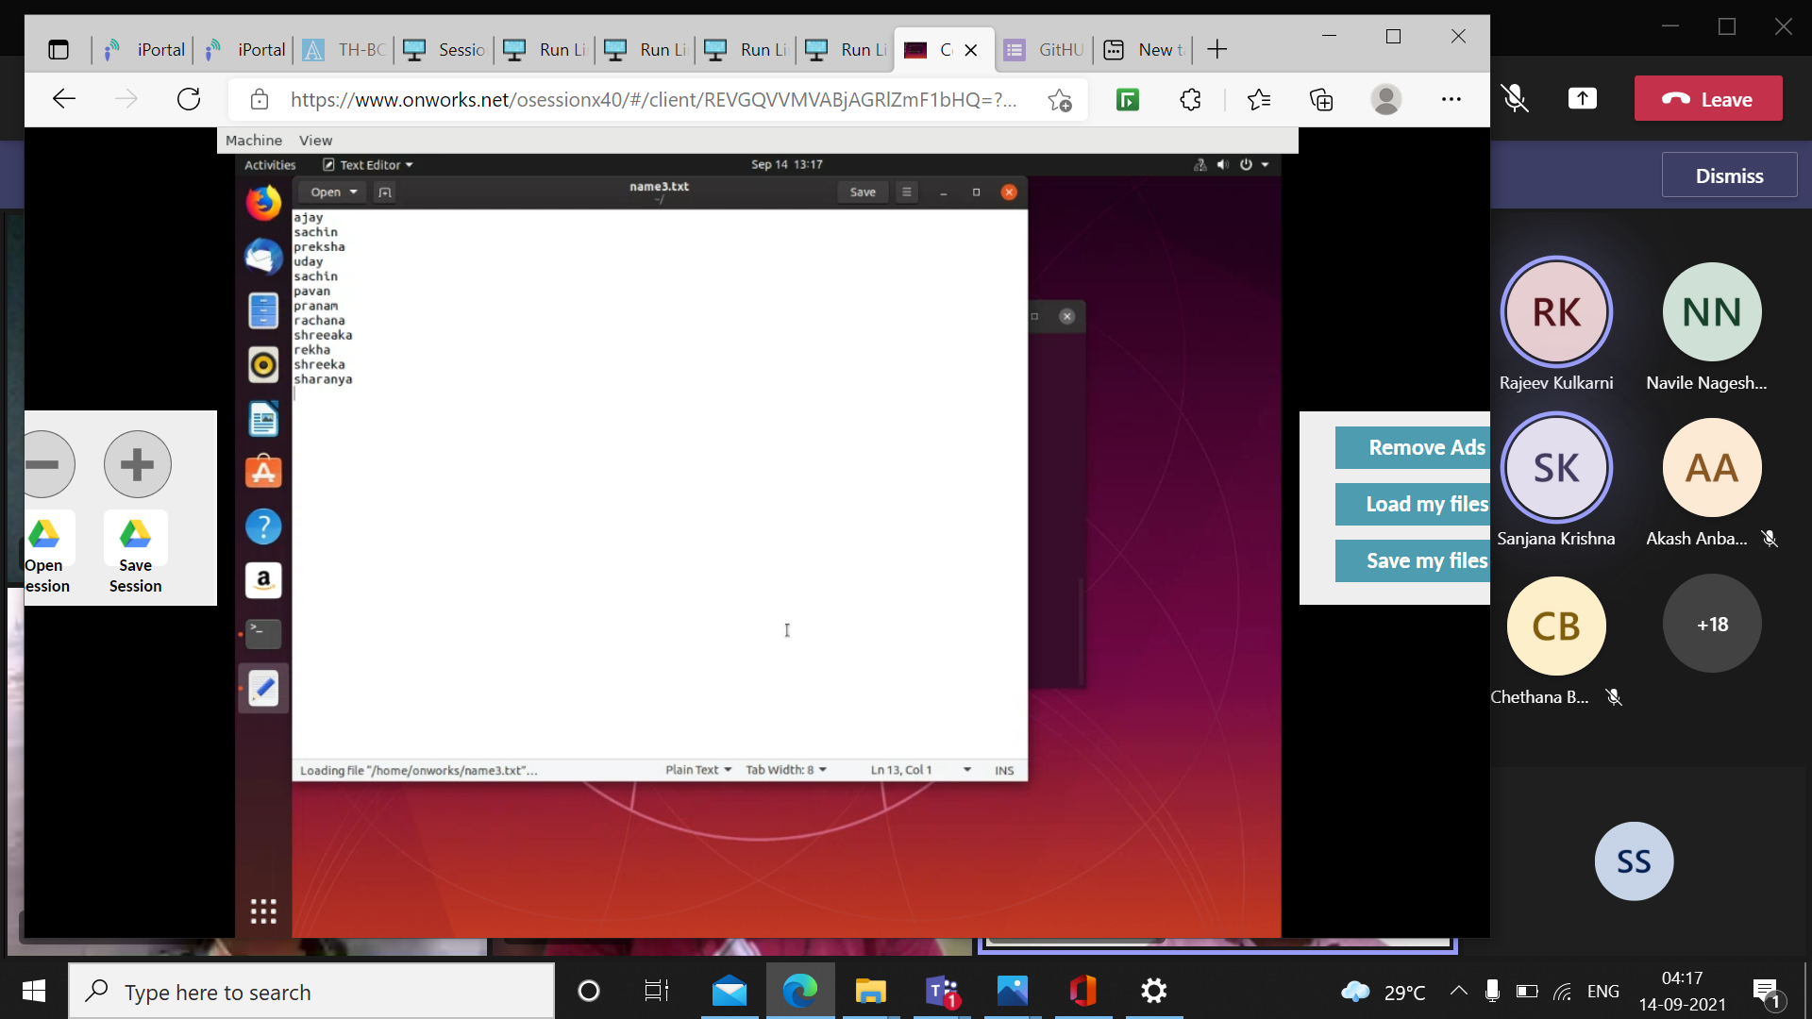

* Uniq sorting discards repeating values and then sorts the list

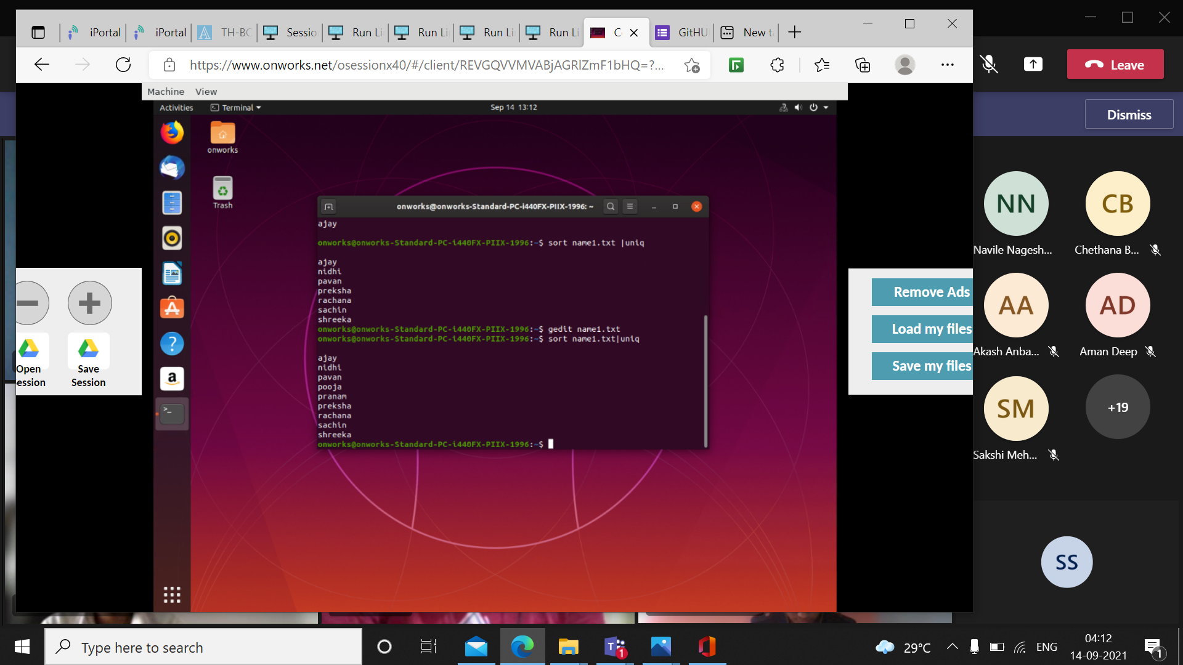

* Diff command returns the difference between two files

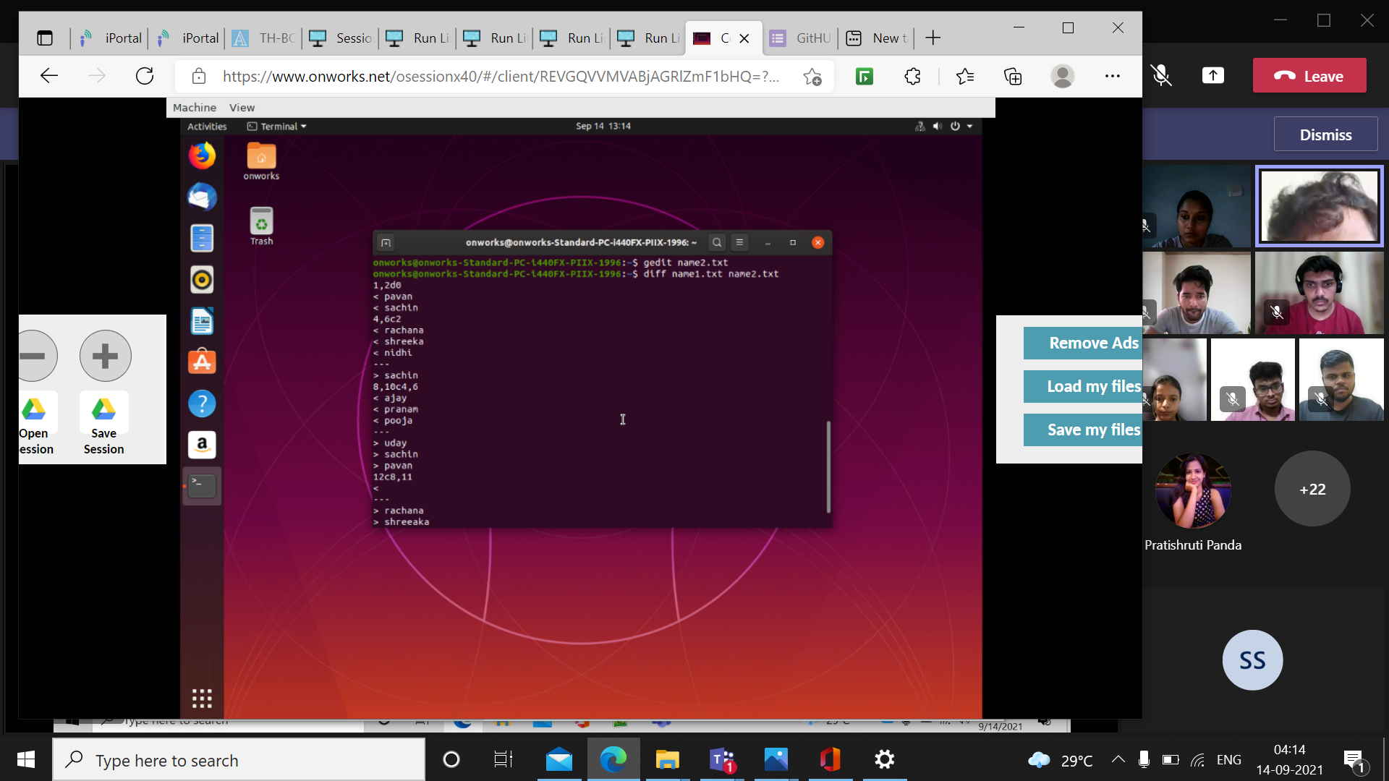

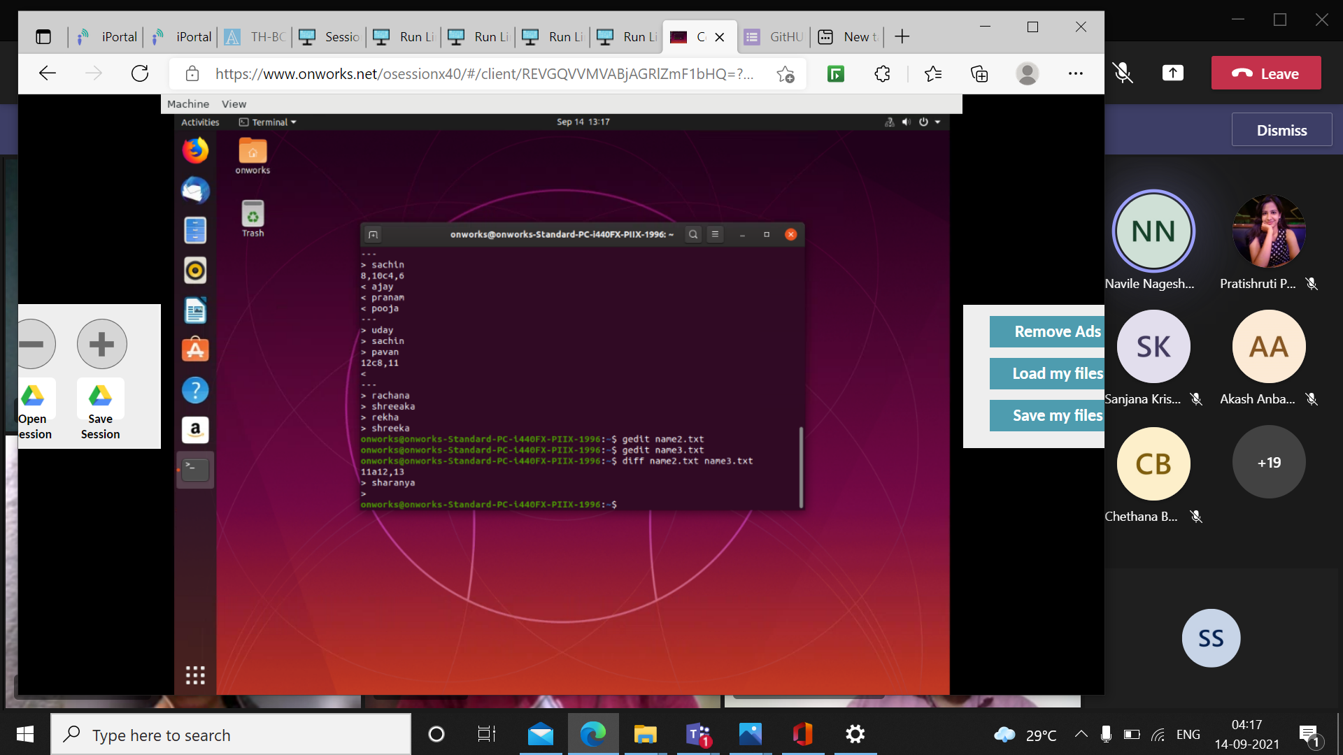

* Killall terminates all the processes that is going to run

